**Brahmapureeswarar Temple – Trichy**

**A Journey Through Art and History**

**Introduction**

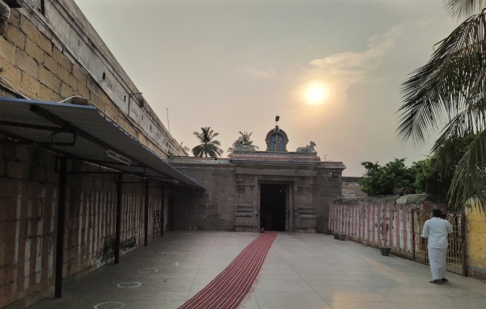

Brahmapureeswarar Temple, located in Trichy (Tiruchirappalli), Tamil Nadu, is a magnificent shrine dedicated to Lord Shiva, known here as Brahmapureeswarar. This ancient temple is renowned for its architectural grandeur, historical significance, and intricate art forms. Situated on the banks of the river Cauvery, the temple attracts devotees and tourists alike, offering a serene and spiritually enriching experience.

**Temple Architecture**

**Dravidian Style**

Brahmapureeswarar Temple exemplifies the Dravidian architectural style, known for its towering gopurams, elaborate carvings, and spacious courtyards.

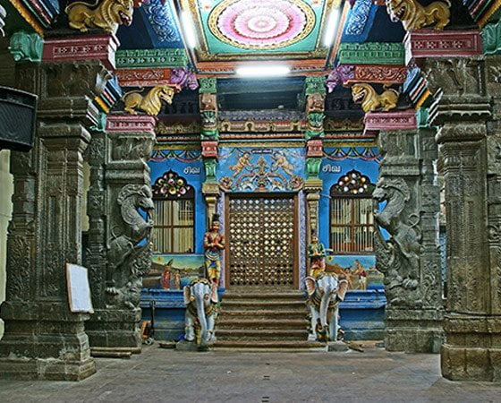

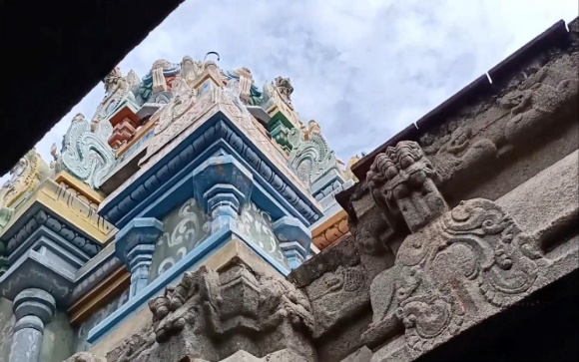

*Temple Architecture*

* **Gopurams**: The temple features imposing gopurams, or gateway towers, adorned with a multitude of sculptures depicting various deities and mythological scenes. The main gopuram stands tall at approximately 70 feet, inviting devotees into the sacred precincts. These gopurams are designed with intricate details and are painted in vibrant colors, reflecting the rich cultural heritage of Tamil Nadu.

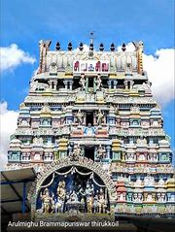

*Entrance Gopuram*

* **Mandapams (Halls)**: The temple has several mandapams, including the Maha Mandapam and the Mukha Mandapam. These halls are used for various religious and cultural activities and are intricately decorated with carved pillars and ceilings. The mandapams are spacious and provide a tranquil atmosphere for meditation and worship.

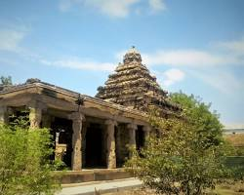 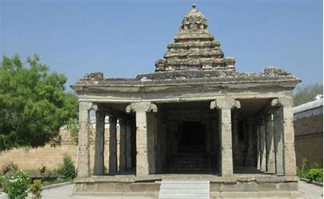

*Mandapams (Halls)*

* **Vimanams (Temple Towers)**: The sanctum sanctorum is surmounted by a vimanam, a beautifully decorated tower that adds to the temple's grandeur. The vimanam is adorned with gold plating and intricate carvings, symbolizing the divine connection between the earthly and the heavenly realms.

**Dimensions**

* **Temple Complex**: The temple complex covers an area of around 2 acres, providing ample space for devotees and tourists to explore and experience its spiritual ambiance. The layout includes multiple shrines, gardens, and water tanks, enhancing the overall aesthetic and spiritual experience.

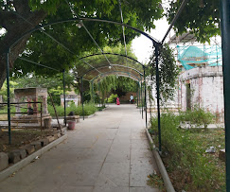 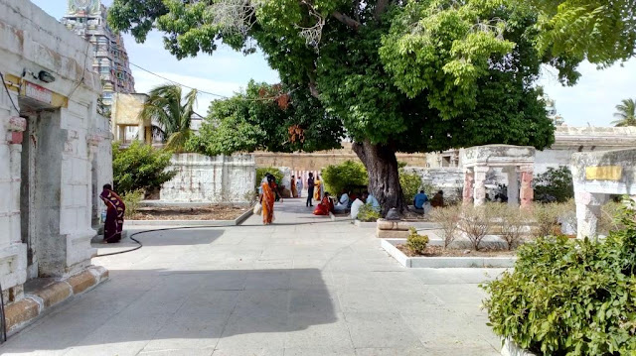

* **Main Sanctum**: The main sanctum, housing the Shiva Lingam, is approximately 15 feet in height, symbolizing the divine presence of Lord Shiva. The sanctum is constructed with black granite, which is believed to have healing properties and is considered sacred.

**Sculpture**

**Intricate Carvings**

The sculptures at Brahmapureeswarar Temple are a testament to the artistic excellence of ancient craftsmen.

* **Deities and Mythological Figures**: The temple walls are adorned with sculptures of various deities, including Lord Shiva, Parvati, Brahma, Vishnu, and Ganesha. These sculptures are detailed and lifelike, showcasing the artisans' skill. Each deity is depicted with specific attributes and poses that convey their significance and powers.

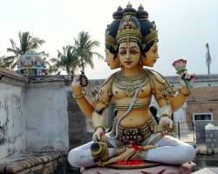

*Figure of Lord Brahma*

**Iconography**

* **Lord Shiva as Brahmapureeswarar**: One of the most striking sculptures in the temple is that of Lord Shiva as Brahmapureeswarar, depicted with a serene expression, symbolizing his role as the Supreme Creator. Therefore, Lord Shiva in this temple is called as Swayambu Lingam.

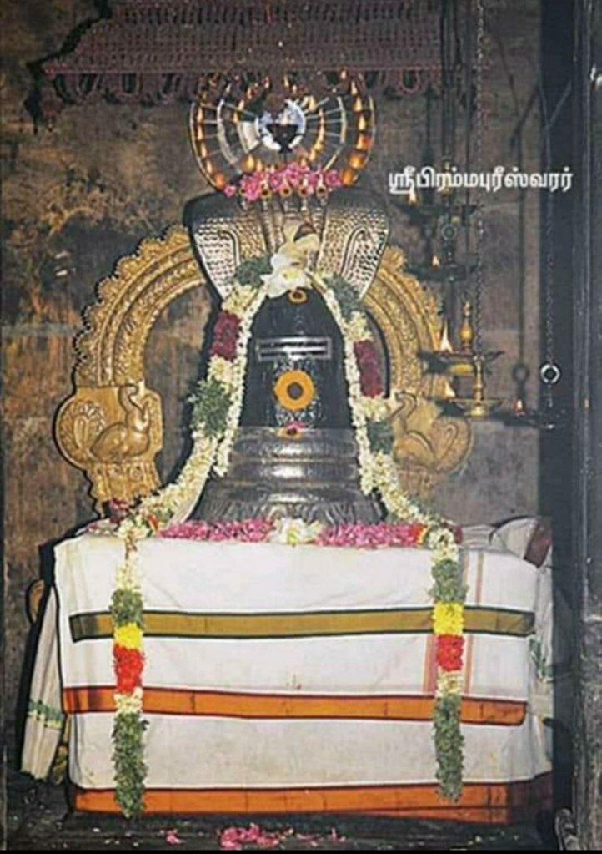

*Lord Shiva (Swayambu Lingam)*

* **Brahma**: The temple also has a unique sculpture of Lord Brahma, which is rare in Shiva temples. This sculpture highlights the temple's significance as a place where Brahma is believed to have worshipped Shiva. Brahma is depicted with four heads, each facing a different direction, symbolizing his role as the creator of the four Vedas.

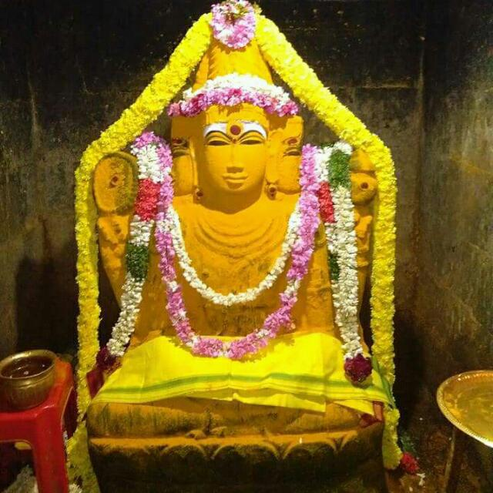

*Brahma Sculpture (In Manjal Kaapu)*

* **The 12 Shiva Lingas:** There are 12 Shiv Lingams in the Temple complex, which includes the garden adjacent to the temple. These Shiva Lingams were installed and worshipped by Brahma.Most of these Shiv Lingams are housed in separate shrines, which are situated around the Brahma Theertham.

Brahma Theertham is the pond from which Brahma took water for performing puja to Shiva.

|  |  |
| --- | --- |
| Tamilnadu Tourism: Brahmapureeswarar Temple, Thirupattur – 12 Shiva Lingams |  |

These 12 shrines of Shiva which comprise the Bramhapureeswarar Temple complex are :

1. Sri Brahmapureeswarar Presiding Deity
2. Sri Pazhamalai Nathar
3. Sri Pathala Eswarar
4. Sri Thayumanavar
5. Sri Manduga Nathar
6. Sri Ekambareswarar
7. Sri Arunachaleswarar
8. Sri Kailasa Nathar
9. Sri Jambukeshwarar
10. Sri Kalathi Nathar
11. Sri Sabthagereswarar
12. Sri Sudharaneswarar

|  |  |  |  |
| --- | --- | --- | --- |
| Tamilnadu Tourism: Brahmapureeswarar Temple, Thirupattur – 12 Shiva Lingams | Tamilnadu Tourism: Brahmapureeswarar Temple, Thirupattur – 12 Shiva Lingams | Tamilnadu Tourism: Brahmapureeswarar Temple, Thirupattur – 12 Shiva Lingams | Tamilnadu Tourism: Brahmapureeswarar Temple, Thirupattur – 12 Shiva Lingams |
|  |  |  |  |

***Some of the 12 Lingas***

* **Patanjali Siddhar Jeeva Samaathi** : Patanjali is one of the 18 Siddhars in the Tamil Siddha (Shaiva) tradition.  Patanjali learned yoga and other disciplines from the famous Yogic Guru, Nandhi Deva (the divine bull of Lord Shiva). Nandhi is one of the 18 Yoga Siddhas (perfected ones) initiated by Lord Shiva. Nandhi Deva’s disciples include Patanjali, Dakshinamoorthy, Thirumoolar, Romarishi, and Sattaimuni.

At least twoplaces in South India claim to be sites where the siddha Patañjali left his body while absorbed in deep meditation (samadhi). One of them is located in Rameshwaram, the other in this temple in Trichy. They also have a painting of Patanjali Siddhar in there.

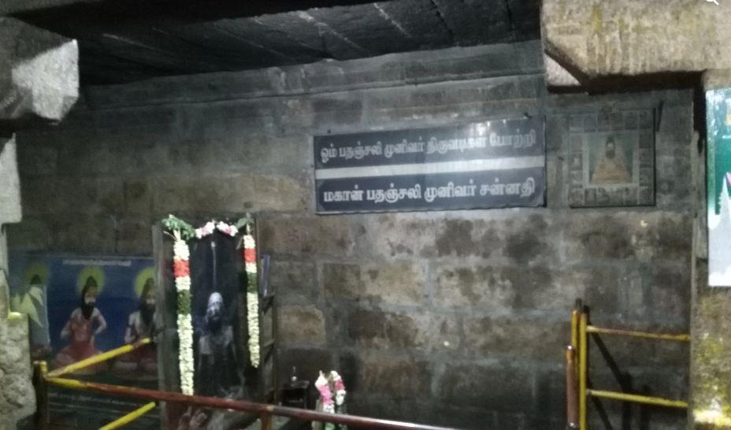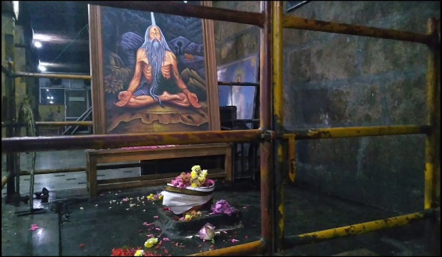

*Pathanjali siddhar Jeeva Samaathi*

**Sthala puranam and temple information**

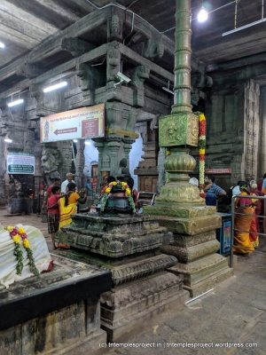

Brahma became proud of his role as Creator of life, and began to consider himself as being more powerful than Siva. As a result, his fifth head was cut off by Lord Siva (that in turn is associated with the story of Bhikshatanar). As penitence, he undertook a pilgrimage where he prayed to Lord Siva at various temples, including this one. He also installed twelve lingams around the temple here. Taking pity on him, Parvati pleaded with Siva on his behalf, and so Brahma was pardoned and also given a separate shrine at this temple. It is believed that Lord Siva gave Brahma the instruction and power to rewrite the fates of devotees who worship at this temple. Devotees first worship Brahma here before worshipping the moolavar.

From the entrance of the temple to the garbhagriham, there are 7 steps, said to represent the 7 days of the week.

The separate shrine for Brahma is in the inner prakaram, with a 6 foot tall idol of Brahma who is always dressed in manjal-kaappu (anointed with turmeric paste). It is considered especially beneficial and auspicious to worship at this temple on Thursday, the day being special to Guru.

There is also a separate Kailasanathar shrine in the temple complex, built by the Pallavas in the style of the Kanchipuram Kailasanathar temple. This shrine has a beautiful Nandi outside it, and is not to be missed.

The temple is a Tevaram Vaippu Sthalam, and is primarily a Chola period construction.

**Sculptures and Frescoes**

Brahmapureeswarar Temple boasts stunning murals and frescoes that enhance its artistic appeal.

* **Depictions of Mythological Events**: The temple walls are adorned with vibrant sculptures depicting various events from Hindu mythology, including the stories of Shiva, Parvati, and Brahma. These carvings are a blend of artistic skill and religious devotion. Each Sculpture is detailed and attracive, capturing the essence of the myths and legends.

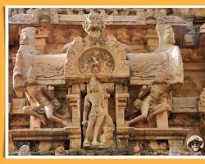

**Traditional Crafts**

**Stone and Metal Work**

The temple is known for its exquisite stone and metal work, which includes:

* **Metal Sculptures**: The temple houses several bronze and metal sculptures of deities, which are used during processions and special rituals. These sculptures are crafted with great attention to detail and are considered sacred. The metalwork reflects traditional techniques passed down through generations, highlighting the rich cultural heritage of the region.
* **Stone Sculptures**: All the intricately carved, exceptionally proportioned,serene Devakoshta figures exude an air of nobility and gentleness. A distinctive feature of the **temple** is the rows of Yalis that have been carved on the base moldings. Each one is distinctive and the ones in the corner have warriors sculpted inside their wide open mouths.

|  |  |
| --- | --- |
| *C:\Users\snaks\Downloads\Cosmos.jpeg*  *Welcoming Women statue* | *Sri Brahmapureeswarar (Swayambhu Lingam) Temple at Tirupattur near ...*  *Lord Narasimha Sculpture* |

**Woodwork**

The temple's doors and chariots used during festivals are adorned with intricate woodwork.

* **Temple Chariots**: The temple chariots used during festivals are beautifully carved with scenes from mythology. These chariots are pulled through the streets during processions, adding to the festive atmosphere. The woodwork is detailed, with each chariot telling a different story through its carvings.

|  |  |
| --- | --- |
|  |  |

*Small Wood Chariot*

* **Wooden Doors**: The temple's wooden doors are intricately carved with floral and geometric patterns, showcasing the craftsmanship of ancient woodworkers. The doors are made from high-quality teak wood and are designed to withstand the test of time while maintaining their beauty.

*Wooden Door*

**Festivals and Cultural Events**

**Mahashivaratri**

Mahashivaratri is one of the major festivals celebrated with great fervor at Brahmapureeswarar Temple.

* **Night-long Vigil**: Devotees gather in large numbers to stay awake all night, offering prayers and participating in special rituals conducted throughout the night. The night is marked by continuous chanting of mantras and recitation of holy scriptures.

**Chithirai Thiruvizha**

Another prominent festival is the Chithirai Thiruvizha, celebrated during the Tamil month of Chithirai (April-May).

* **Processions and Rituals**: The festival involves grand processions, special poojas, and cultural performances. The temple chariots, beautifully decorated for the occasion, are a major attraction during the processions.

**Navaratri**

Navaratri, dedicated to the worship of Goddess Durga, is also celebrated with enthusiasm at Brahmapureeswarar Temple.

* **Nine Nights of Celebration**: The nine nights are filled with special prayers, cultural performances, and elaborate decorations. Each day is dedicated to a different form of the goddess, with rituals and offerings tailored accordingly.

**Conclusion**

Brahmapureeswarar Temple in Trichy is not only a place of worship but also a repository of ancient art and architecture. The temple's intricate sculptures, stunning paintings, and exquisite traditional crafts offer a glimpse into the rich cultural heritage of Tamil Nadu. Visitors to this temple can experience a unique blend of spirituality and artistic excellence, making it a must-visit destination for those interested in India's cultural and religious history.